Jan Rehwaldt, 2012-02-20, University of Tartu

Exercise 3, Project Management

**Situation 1**

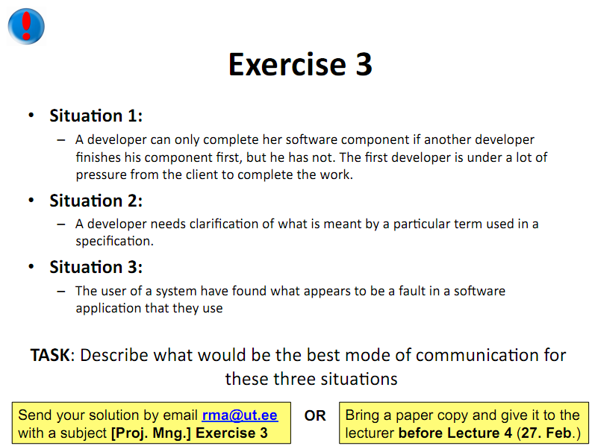

Ideally, the second developer gets informed immediately via face-to-face meeting, because this makes it easier to stress the importance of the task to be finished as soon as possible. For this to work both have to work at a similar work place within the same time zone. Alternatively, a telephone call is a good option if the work place is different. As last resort indirect communication media, such as email, can be used.

**Situation 2**



If the creator of the specification is around asking him directly would be the fastest option. On the other hand is writing an email totally sufficient if the information is not required to be available within a few minutes.

**Situation 3**



Generally the vendor provides support hotlines and email addresses or online feedback forms, which are meant to be the primarily communication channel for bug reports or easy questions. If the user is an employee the company’s own IT department rather than the software vendor should be contacted first. They are responsible for requesting a solution from the software provider.